Problem 2

a) Most of the data buses A and B look to be in a federated configuration, with a single processor and several other instruments connected to a single data bus. There is a Command and Data Subsystem, that looks to be in a more centralized configuration, but in the end, it is still connected to the federated data bus configuration.

b) The MESSENGER data bus is a little bit strange, but mostly looks like a distributed configuration. From the instruments point of view, each processor looks like it can talk to a number of different instruments, but it is not clear whether or not the arrows are indicating a bus, or just connections between the objects. If the arrows did not indicated a data bus, then this would be an open or centralized configuration.

c) The NEAR C&CH architecture with respect to only the NIS/MAG, MIS, and the X/gamma Ray processors, each processor looks to be in a centralized or open configuration. Probably a centralized configuration, since each processor was specially designed for each of those instruments.

d) Each of the Class B components would need to be hooked in a parallel configuration, in order to increase the reliability. Below are the calculations based on the reliability equation from the Monte Carlo Lecture:

$$\frac{ln⁡(1-0.996)}{ln⁡(0.2)}=3.43→ceil\left(3.43\right)= 4$$

There will need to be 4 units in parallel to achieve at least a reliability of 0.996.

Problem 3

a) I assume the Low-Gain antenna has a gain of 1.5 dB. I also assume the High-gain antenna half-power beam-width is 3 degrees.

b) The Eb/No value should be 5.1 dB by finding the input power required based on the design Eb/No, which is the summation of the required Eb/No, the implementation loss, and the link margin required. The answer can be verified by finding the required power input and using the Eb/No equation to solve for that required power input.

c)

**Table 1: Cassini estimated communication system info**

|  |  |  |
| --- | --- | --- |
| Comm System |  |  |
| 1.0 S/C Antenna Gain | |  |
| 1.1 High Gain |  | 48.74 dB |
| 1.2 Low Gain |  | 1.50 dB |
| 2.0 DSN Antenna Gain | | 68.00 dB |
| 3.0 Comm Subsystem Input Power | | 79.71 W |
| 4.0 RF Power Tx by S/C | | 19.93E+00 W |
| 5.0 RF Power Rc by DSN | | 25.69E-18 W |
| 6.0 C/N |  | 5.10 dB |
| 7.0 Eb/No |  | 5.10 dB |

d)

**Table 2: Cassini C&DH mass and power estimates**

|  |  |
| --- | --- |
| C&DH System | Each |
| 1.0 Mass | 95.28 kg |
| 2.0 Power | 78.00 W |
|  |  |

e)

**Table 3: Mass table for the Cassini mission**

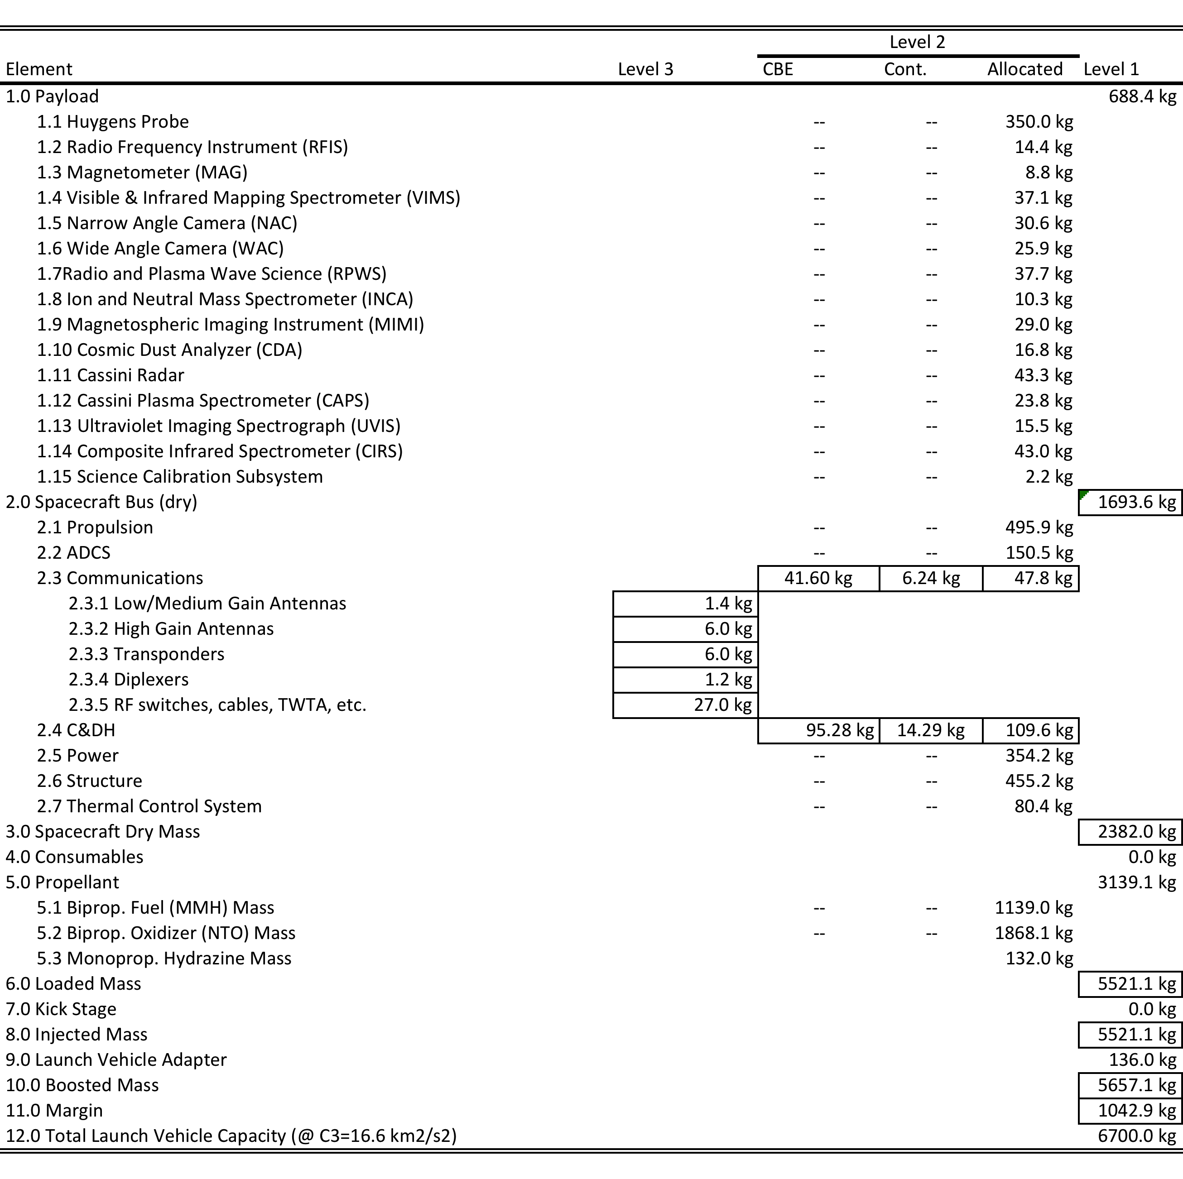

f)

The Comm subsystem was off by 118 kg or about 73.93% error, The D&DH Subsystem was off by 34.7 kg or around 57.23% error, The communication power estimate was off by 0.4 watts or around 0.48% error, and the C&DH power was off by 25.4 watts or around 48.29% error. The main differences seem to come with the estimates of what redundant systems are needed and how much redundancy is needed.